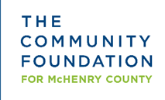

2020 Scholarship for Wauconda High School Students

Lorna D. Rowland Scholarship
The Lorna D. Rowland Scholarship was established to honor the memory of Lorna Rowland and the contributions she made to the community. The purpose of this scholarship is to encourage women to study social sciences and/or social issues.

Eligibility: Female student graduating from Wauconda High School who holds a GPA of 3.2 or higher (based on a 4.0 scale) and has taken at least 1.5 years of elective classes in Current Issues, Sociology, Psychology, 20th Century World History, Theater Arts, World Literature or Speech. Applicants will also have participated in at least one year of a non-sport related extracurricular activity. Scholarship of $1,000.

