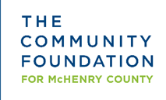

2020 Scholarship for Rolling Meadows High School Students

Allen Family Scholarship
The Allen Family Scholarship was established in memory of Robert and Georgia Allen to assist Rolling Meadows High School graduating seniors to continue in a higher education program of their choice. This scholarship is to assist a student in achieving a two- or four-year degree.

Eligibility: Students graduating from Rolling Meadows High School who hold a grade point average of 3.5 or higher (based on 4.0 scale) and demonstrate commitment to volunteer service in their community. Additional preference will be given to applicants whose parent has served, or is currently serving in the United States Military. Scholarship of $500.

